**Problem Statement:**

The problem is to manage dynamic memory in a safe and efficient way, avoiding memory leaks, dangling pointers, and other issues that arise when using raw pointers in C++. We will demonstrate the use of std::unique_ptr, std::shared_ptr, and std::weak_ptr smart pointers to solve this.

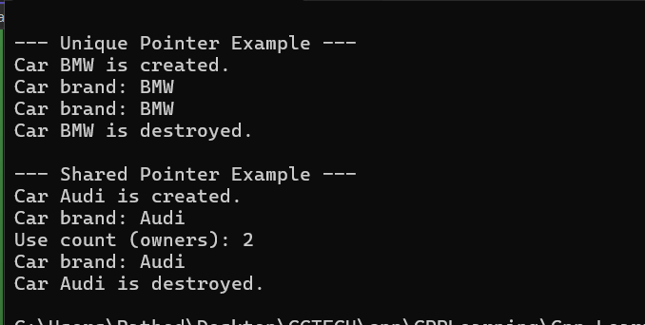

**Learnings-**

• **Unique Pointer Example**:

* We create a Car object using unique_ptr, which ensures exclusive ownership.
* When the ownership is transferred (via std::move), the previous owner loses access to the object.

• **Shared Pointer Example**:

* We create a Car object using shared_ptr. Multiple shared_ptr objects can manage the same memory. We track the reference count using use_count() to show how many owners there are.